sMART BOOKING SYSTEM DOCUMENTATION
Crown coders
Abstract
Mission: Build a Smart Services Booking Platform using open-source tech, automated pipelines, and an AI-powered assistant.
Table of Contents
Product Vision Statement 2
Target Users 2
Proposed Solution 3
Scope Definition 4
Success Criteria (v1.0) 5
Future Vision (Post v1.0) 6
User Stories Documentation 6
EPIC 1 — Authentication & User Management: 6
EPIC 2 — Service Management: 7
EPIC 3 — Booking Engine; 7
EPIC 4 — AI Assistant: 8
EPIC 5 — Web Application: 8
EPIC 6 — Mobile Application: 9
EPIC 7 — DevOps & Automation: 9
Entity Relationship Diagram: 10
Functional Requirements 10
Non-Functional Requirements 12
Functional Requirements Traceability Matrix 13
Non-Functional Requirements Traceability Matrix 14
System architecture 15
High level layered system architecture diagram: 16
System Layers Description 18

Group members - Crown Coders
Mbali Mabona - Group Leader
Phathisa Ndaliso
Isabela Tlhakudi
Nozwelo Sibiya
Nqobile Magwaza

Product Vision Statement
We are building a secure and intelligent therapy booking platform accessible via web and mobile applications, enabling users to easily browse services, book therapy sessions, and receive automated support through AI-driven assistance, while ensuring operational efficiency through admin management and scalable infrastructure.
Our vision is to simplify access to therapy services by combining streamlined booking, intelligent automation, and reliable system performance.

Target Users
Users (Clients)
Individuals seeking therapy services who need:
- Easy registration and secure login
- Ability to browse available therapy services
- Seamless booking process
- Smart time-slot validation
- Protection from double bookings
- Booking status tracking
- AI chatbot assistance for FAQs and booking suggestions

Admin
Platform managers responsible for:
- Creating and managing services
- Managing user access
- Monitoring bookings
- Updating booking statuses
- Ensuring platform reliability

Core Problem Being Solved
Many service-based businesses still rely on manual or semi-manual booking processes, which introduce inefficiencies and operational risks.
The key problems include:
- Scheduling conflicts due to manual coordination
Without automated validation, appointments are often managed through calls, messages, or spreadsheets, increasing the likelihood of errors.
- Double bookings and overlapping time slots
Lack of real-time time-slot validation results in multiple users booking the same slot, causing customer dissatisfaction and operational disruption.
- No instant support for common user questions
Users frequently need clarification about availability, service duration, or booking steps, but traditional systems do not provide immediate assistance.
- Limited automation and poor scalability
Many booking platforms lack structured workflows, automated status management, and scalable architecture, making growth difficult.
- Restricted accessibility across devices
Systems that are not optimized for both web and mobile limit user convenience and reduce overall engagement.

Proposed Solution
To address the identified challenges, we will develop a cross-platform Smart Services Booking Platform accessible via both web and mobile applications.
The system will:
- Enable secure user registration and role-based access control
Users can create accounts and log in securely using JWT-based authentication, with clearly defined roles (User / Admin) to enforce proper authorization.
- Allow administrators to add therapists and manage bookings
Admin users can define available therapist, their information such as years of experience, qualification, practice number/license, ensuring trust for patient users.
- Provide seamless service browsing and booking
Users can easily explore available services(what kind of therapy) and complete bookings through a structured, user-friendly interface.
- Automatically validate time slots and prevent double bookings
The booking engine will enforce business rules to prevent overlapping appointments, eliminate scheduling conflicts, and ensure data integrity.
- Offer real-time booking status tracking
Users can view the status of their bookings (e.g., Pending, Approved, Declined), and update both therapist and patient by email to improve transparency and communication.
- Integrate an AI-powered chatbot
The platform will include an AI assistant to answer frequently asked questions, guide users through the booking process, and recommend available time slots and quick information about the therapist.
- Leverage modern DevOps practices for scalability and reliability
The system will use containerization (Docker), automated CI/CD pipelines, monitoring, and logging to ensure high performance, maintainability, and future scalability.

Scope Definition
IN SCOPE (Version 1.0)
Core Features:
- User registration & login
- Role-based access control (User / Admin)
- Service creation (Admin)
- Service browsing (User)
- Booking creation
- Time-slot validation
- Double-booking prevention
- Booking status management (e.g., Pending, Approved, Declined)
- AI chatbot for FAQs & booking suggestions

Platforms
- Web application (full functionality)
- Mobile application (basic booking flow)
- Technical & Infrastructure
- CI/CD automation
- Dockerized setup
- Monitoring & logging

OUT OF SCOPE (Later Phases)
- Payment integration
- SMS notifications
- Multi-location support
- Video consultations
- AI voice assistant

Success Criteria (v1.0)
The product will be considered successful if:
- Users can register and log in securely.
- Admin can create services(add therapist) and manage bookings.
- Users can browse and successfully book session.
- The system prevents double bookings.
- Time-slot validation works reliably.
- Booking statuses update correctly.
- AI chatbot responds accurately to FAQs.
- The system runs reliably on web and mobile.
- CI pipelines deploy successfully with minimal manual intervention.
- Application monitoring provides clear logs and system visibility.

Future Vision (Post v1.0)
- Integrated online payments
- SMS reminders
- Multi-branch/location support
- Secure video consultations
- AI voice-based booking assistant

User Stories Documentation

EPIC 1 — Authentication & User Management:
ID | User Story | Acceptance Criteria
1.1 | As a new user, I want to register an account so that I can book services on the platform. | Enter name, email, password  Email must be unique  Password ≥ 8 characters  Password hashed  JWT generated  Redirect to dashboard  Error if email exists
1.2 | As a registered user, I want to log in securely so that I can access my bookings. | Login via email/password  Error for invalid credentials  JWT issued  Token stored securely  Redirect to dashboard  Protected routes require token
1.3 | As an admin, I want restricted access to administrative features so that only authorized users can manage services. | Roles: USER/ADMIN  Only ADMIN manages services  USER blocked from admin endpoints  403 for unauthorized access
1.4 | As a logged-in user, I want to view and update my profile so that my account details remain accurate. | View profile  Update name  Changes saved  Only owner can update profile

EPIC 2 — Service Management:
ID | User Story | Acceptance Criteria
2.1 | As an admin, I want to create a new service so that users can book it. | Input name, description, duration, price  Duration positive  Saved in DB  Visible in list  Admin only
2.2 | As an admin, I want to update service details so that information remains accurate. | Modify details  Changes reflect immediately  Validation on duration & price
2.3 | As a user, I want to view available services so that I can choose one to book. | Display name, duration, price  Loads within 2 seconds  Accessible to users

EPIC 3 — Booking Engine;
ID | User Story | Acceptance Criteria
3.1 | As a user, I want to book a service at a selected time so that I can reserve my slot. | Select date & time  Auto-calc end time  Booking saved  Confirmation displayed
3.2 | As a system, I must prevent double bookings so that time slots are not duplicated. | Check overlaps  Reject conflicts  Return 409 Conflict  Transaction rollback
3.3 | As a user, I want to book only valid future time slots so that bookings are realistic. | No past dates  No outside working hours  Validation errors shown
3.4 | As an admin, I want to update booking status so that bookings can be confirmed or cancelled. | Valid status transitions  Only ADMIN confirms  Users cancel own bookings
3.5 | As an admin, I want to view all bookings so that I can manage the system efficiently. | Dashboard shows all bookings  Filter by date/status  Paginated results

EPIC 4 — AI Assistant:
ID | User Story | Acceptance Criteria
4.1 | As a user, I want the AI assistant to answer common questions so that I can get help instantly. | Responds within 3 seconds  Answers service & booking questions
4.2 | As a user, I want AI to suggest optimal time slots so that I can book less busy hours. | Checks availability  Suggests valid free slots
4.3 | As a user, I want AI to guide me through booking so that I understand each step. | Step-by-step instructions  Redirect to booking page
4.4 | As a user, I want AI to remember conversation context so that responses feel intelligent. | Maintains session memory  Relevant responses  No hallucinated answers

EPIC 5 — Web Application:
ID | User Story | Acceptance Criteria
5.1 | As a user, I want a dashboard overview so that I can quickly access key features. | Shows upcoming bookings  Quick navigation  Responsive design
5.2 | As a user, I want an interactive calendar so that I can visually select time slots. | Shows availability  Real-time updates  Booked slots marked
5.3 | As a user, I want to view my bookings so that I can manage them. | Shows booking history  Cancel future bookings  Status visible
5.4 | As an admin, I want an admin dashboard so that I can manage services and bookings. | Service CRUD  Booking management  Admin restricted

EPIC 6 — Mobile Application:
ID | User Story | Acceptance Criteria
6.1 | As a mobile user, I want secure login and registration so that I can access the platform on my phone. | Login/register works  JWT stored securely  Protected screens enforced
6.2 | As a mobile user, I want to browse services so that I can book easily. | Services load correctly  Mobile-friendly UI  Fast loading
6.3 | As a mobile user, I want to book services easily so that I can reserve slots on the go. | Select service/date/time  Confirmation shown  Overlap validation enforced
6.4 | As a mobile user, I want to view past bookings so that I can track my activity. | Displays previous bookings  Status clearly visible

EPIC 7 — DevOps & Automation:
ID | User Story | Acceptance Criteria
7.1 | As a developer, I want a containerized environment so that the project runs consistently across machines. | docker-compose runs client/server/db  Single command setup  Env variables configured
7.2 | As a developer, I want automated testing in CI so that broken code cannot be merged. | Lint runs automatically  Tests run automatically  Merge blocked if failing
7.3 | As a developer, I want PR preview environments so that features can be tested before merging. | PR generates preview link  Mirrors staging environment
7.4 | As a product owner, I want automatic deployment to production so that releases are efficient. | Merge to main triggers deployment  No manual SSH required
7.5 | As a system administrator, I want system monitoring enabled so that issues are detected early. | Error logging enabled  Uptime monitoring active  Performance metrics tracked

Entity Relationship Diagram:
Click the link to view a clear diagram

Functional Requirements
User and Role Management:
- The system should allow clients to register and log into the platform.
- The system should allow only the admin to create, update, and deactivate therapist accounts.
- The system should prevent therapists from self-registering on the platform.
- The system should support role-based access for clients and admins.
- The system should allow the admin to manage user accounts.

Therapist Profile Management:
- The system should allow the admin to create therapist profiles.
- The system should allow therapists to view and update their professional information.
- The system should allow therapists to define their availability for therapy sessions.
- The system should store therapist specializations and session types.

Booking and Confirmation Workflow:
- The system should allow clients to request therapy session bookings.
- The system should store booking requests with a pending status.
- The system should allow the admin to view all pending booking requests.
- The system should allow the admin to approve or reject booking requests.
- The system should update the booking status to be confirmed upon admin approval.
- The system should prevent double bookings for the same time slot.
- The system should allow the admin to cancel or reschedule bookings when required.
- The system should store booking history for reporting and auditing purposes.

Notifications:
- The system should notify clients when a booking has been confirmed.
- The notification sent to the client should state: “Your booking is confirmed.”
- The system should notify therapists when a new booking has been confirmed.
- The notification sent to the therapist should state: “You have a new booking.”
- The system should notify users of any booking cancellations or changes.
AI Chatbot Assistance:
- The system should provide an AI-powered chatbot to assist users.
- The chatbot should answer frequently asked questions related to therapy bookings.
- The chatbot should guide clients through the booking request process.
- The chatbot should recommend available time slots based on therapist availability.
- The chatbot should redirect users to admin support when necessary.

Administration and Reporting:
- The system should allow the admin to view all bookings in the system.
- The system should allow the admin to generate basic system usage and booking reports.
- The system should log system activities for monitoring and auditing purposes.

Non-Functional Requirements
Security:
- The system should enforce role-based access control.
- The system should restrict therapist creation and booking confirmation privileges to admins only.
- The system should encrypt sensitive user data during transmission and storage.
- The system should comply with data protection and privacy principles.

Performance:
- The system should respond to user actions within three seconds under normal operating conditions.
- The system should support a minimum of 30 concurrent users.

Reliability and Availability:
- The system should maintain at least ninety-nine percent system availability.
- The system should support automated data backups.
- The system should recover from system failures without data loss.
Scalability:
- The system should support horizontal scaling through container-based deployment.
- The system should allow future expansion to support additional therapists and services.

Usability and Accessibility:
- The system should provide a user-friendly and intuitive interface.
- The system should be accessible on both web and mobile platforms.
- The system should support basic accessibility standards.

Maintainability and DevOps:
- The system should follow Gitflow branching standards.
- The system should include automated testing and continuous integration of pipelines.
- The system should be containerized using Docker.
- The system should support automated deployment processes.

Functional Requirements Traceability Matrix
Requirement Description | User Role | System Component | Verification Method
Clients can register and log in to the system | Client | Authentication Module | Functional Testing
Only the admin can create and manage therapist accounts | Admin | User Management Module | Access Control Testing
Therapists cannot self-register | Therapist | Authentication Module | Security Testing
Role-based access control is enforced | Admin | Authorization Layer | Security Testing
Admin can create and manage therapist profiles | Admin | Therapist Management Module | Functional Testing
Therapists can manage availability | Therapist | Scheduling Module | Functional Testing
Clients can request therapy bookings | Client | Booking Module | Functional Testing
Booking requests are stored as pending | System | Booking Module | Database Testing
Admin can approve or reject booking requests | Admin | Admin Dashboard | Functional Testing
Booking status updates to confirmed after approval | System | Booking Module | Integration Testing
Double bookings are prevented | System | Scheduling Logic | Constraint Testing
Admin can cancel or reschedule bookings | Admin | Booking Module | Functional Testing
Clients receive booking confirmation notifications | Client | Notification Service | Integration Testing
Therapists receive new booking notifications | Therapist | Notification Service | Integration Testing
Users are notified of booking changes | Client / Therapist | Notification Service | Functional Testing
AI chatbot assists users with booking queries | Client | AI Chatbot Service | User Acceptance Testing
AI chatbot recommends available time slots | Client | AI Chatbot + Scheduling Module | Integration Testing
Admin can view all bookings | Admin | Admin Dashboard | Functional Testing
Admin can generate booking reports | Admin | Reporting Module | Functional Testing
System activities are logged | System | Logging Module | Audit Testing

Non-Functional Requirements Traceability Matrix
Requirement Category | Requirement Description | System Component | Verification Method
Security | Role-based access control is enforced | Authorization Layer | Security Testing
Security | Sensitive data is encrypted | Security Layer | Penetration Testing
Performance | System responds within 3 seconds | Backend APIs | Performance Testing
Performance | Supports concurrent users | Backend Infrastructure | Load Testing
Reliability | System maintains high availability | Deployment Infrastructure | Monitoring & Uptime Tests
Reliability | Automated backups are implemented | Database System | Backup & Recovery Testing
Scalability | System supports horizontal scaling | Container Infrastructure | Scalability Testing
Usability | User interface is intuitive | Frontend Application | Usability Testing
Accessibility | Platform works on web and mobile | Frontend & Mobile App | Compatibility Testing
Maintainability | CI pipelines are implemented | DevOps Pipeline | Pipeline Validation
Maintainability | Containerized deployment is used | Docker Environment | Deployment Testing

System architecture
Chosen Architecture and why:
Modular Monolith
We chose a modular monolith instead of microservices because we are a team of five building a first version (v1 MVP) within three weeks. This approach suits our team size and time limits, as it is easier to build, manage, and deploy. It allows us to keep all parts of the system in one application while still separating features like booking, users, and the AI chatbot. This reduces complexity, helps avoid data issues in the booking process, and lets us focus on delivering a working system. The design also allows us to split the system into microservices in the future if the project needs to grow.
High-Level System Overview:
At a high level, users interact with the system through a web application or a mobile app. These applications send requests to a backend API, which acts as the central control point of the system. The backend is responsible for user authentication, enforcing business rules such as booking validation, and storing data in the database. The AI chatbot does not run locally but communicates with an external AI service to provide assistance and booking recommendations. DevOps tools are used to automate testing, building, and deployment. This clear separation of responsibilities makes the system easier to manage, maintain, and scale in the future.

High level layered system architecture diagram:
The purpose of the High-Level System Architecture Diagram is to visually represent the structural components of the system, their interactions, and the flow of data between users, application layers, external services, and infrastructure.
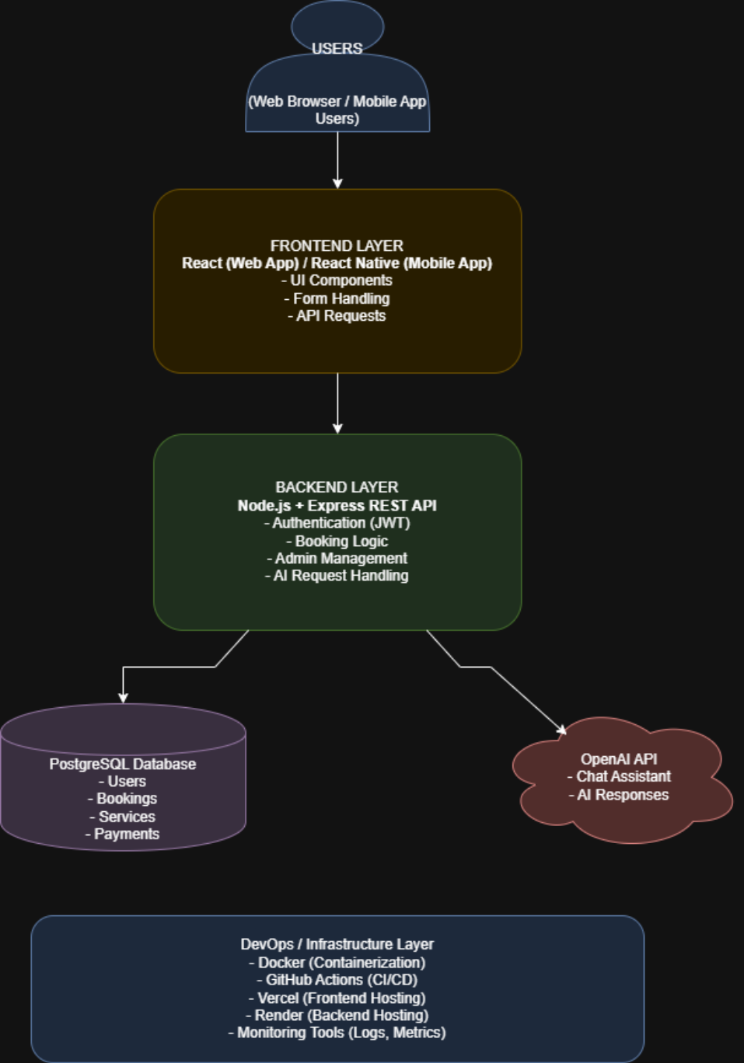Figure 1 : high level layered system architecture diagram

System Layers Description
Frontend Layer:
The frontend layer is the part of the system that users interact with directly through the web or mobile application. It is responsible for displaying the user interface, handling user input such as booking forms, and sending requests to the backend API. This layer does not contain business logic; it focuses on usability, navigation, and presenting data returned from the backend.

Backend Layer:
The backend layer acts as the core of the system. It handles user authentication, applies business rules such as booking validation, and manages communication between the frontend, database, and external services. In this modular monolith design, different features such as bookings, users, admin management, and AI requests are separated into modules within the same application, making the system easier to maintain and extend.

Database Layer:
The database layer is responsible for storing and managing all persistent data in the system. This includes user accounts, services, bookings, availability slots, and payment-related information. A single database is used to ensure data consistency, especially for booking operations where accuracy and reliability are critical.

AI Integration Layer:
The AI layer connects the system to an external AI service used for the chatbot functionality. It handles sending user queries to the AI service and receiving responses that are then shown to users. Keeping the AI service external reduces system complexity while still allowing intelligent features such as answering questions and suggesting booking options.

DevOps / Infrastructure Layer:
The DevOps and infrastructure layer supports how the system is built, tested, deployed, and monitored. Tools such as containerisation and CI/CD pipelines automate deployments and reduce manual errors. Hosting and monitoring services ensure that both the frontend and backend remain available, stable, and easy to update throughout development and deployment.

